**Year 11 ATAR Chemistry**

Task 10: Intermolecular Forces & Solubility Test

Weighting: 5% of Year Grade

NAME: ______________________________

TEACHER’S NAME: ___________________

**Required Resources:**

**___ / 56**

Blue or Black pen, Ruler, Calculator, Chemistry Data Book

**Not Allowed:**

Notes, Personal Periodic Tables

|  |  |  |  |
| --- | --- | --- | --- |
| **SECTION** | **NUMBER OF QUESTIONS** | **AVAILABLE MARKS** | **MARK** |
| Multiple Choice | 10 | 10 |  |
| Short Answer | 10 | 30 |  |
| Calculations | 3 | 16 |  |

**SECTION A: MULTIPLE CHOICE SECTION (10 marks)**

INSTRUCTIONS

For each question, shade the box to indicate your answer. Use only a blue or black pen to shade the boxes. For example, is b is your answer:

If you make a mistake, place a cross through the square and shade your new answer, for example d:

If you then want to use your first answer b, cross out d and circle b:

1. Which of the following molecules would have the highest boiling point?
   1. Phosphorus pentachloride (PCl5)
   2. Cyclohexane (C6H12)
   3. Propan-1-ol (CH3CH2CH2OH)
   4. Hydrobromic acid (HBr)
2. Which of the following statements is incorrect when describing carbon dioxide?
   1. Carbon dioxide contains polar bonds
   2. Carbon dioxide molecules are held together by dipole-dipole forces
   3. Carbon dioxide is a non-polar molecule
   4. The central atom in carbon dioxide has no lone pairs of electrons
3. The bond angle between each of the four hydrogen atoms in methane is 109o. Why is this?
   1. It is the only way that hydrogen atoms will fit around the carbon atom
   2. The spacing of the hydrogen atoms makes it easier for them to form intermolecular forces with other atoms
   3. The electron pairs around the carbon atom repel each other, maximising the distance between them
   4. It maximises methane’s polarity
4. A molecule with a shape that is trigonal pyramidal has:
   1. 4 bonding pairs of electrons
   2. 3 bonding pairs of electrons
   3. 4 bonding pairs of electrons and one lone pair of electrons
   4. 3 bonding pairs of electrons and one lone pair of electrons
5. Which of the following statements is incorrect?
   1. A substance can contain polar bonds but be non-polar overall
   2. A substance that is geometrically symmetrical is always polar
   3. Elemental molecules are always non-polar
   4. A polar molecule can form attractions to ions
6. Which of the following three molecules will have the lowest vapour pressure?

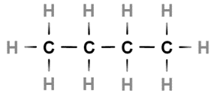

* 1. Butane
  2. Methylpropane
  3. Cyclobutane
  4. They will all have the same vapour pressure

1. Which of the following molecular shapes has three electron groups around the central atom?
   1. Tetrahedral
   2. Trigonal pyramidal
   3. Trigonal planar
   4. Both trigonal pyramidal and trigonal planar
2. The two molecules shown below are similar in molecular structure in mass:

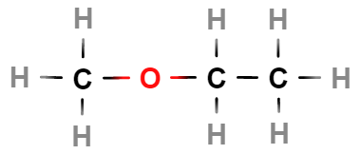 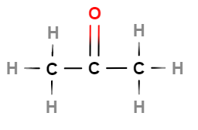

methoxyethane acetone

Each molecule contains three carbon atoms and one oxygen atom, however methoxyethane has a boiling point of 6.8oC and acetone has a boiling point of 56oC. What is a correct explanation of this?

1. The oxygen atom in methoxyethane is not as accessible for hydrogen bonding
2. Oxygen atoms that form single bonds do not hydrogen bond with other molecules
3. Acetone is a shorter molecule which allows it to form more intermolecular forces
4. The more hydrogen atoms a molecule has, the lower the boiling point
5. The following two molecules will form which of the following intermolecular forces with each other?

Ammonia Ethanol

1. Dipole-dipole forces and hydrogen bonds
2. Dispersion forces and hydrogen bonds
3. Hydrogen bonds
4. Dispersion forces, dipole-dipole forces and hydrogen bonds
5. Increasing the temperature of a solution will cause the solubility of a gas to:
6. Decrease
7. Increase
8. Remain constant
9. Randomly fluctuate

**SECTION B: SHORT ANSWER SECTION (30 marks)**

1. Draw Lewis structures for the following substances:

|  |  |
| --- | --- |
|  |  |
| **Sulfur dichloride (SCl2)** | **Calcium nitride (Ca3N2)** |
|  |  |
| **Ammonium chloride (NH4Cl)** | **Hydrogen cyanide (HCN)** |

(4 marks)

1. Identify the following molecular shapes and provide one example of a molecule with that shape.

|  |  |  |
| --- | --- | --- |
| **Name of shape** | **Diagram of molecule** | **Example of molecule** |
|  |  |  |
|  |  |  |
|  |  |  |

(6 marks)

1. The following graph shows the boiling points of simple covalent compounds that include hydrogen. One line represents the trend in boiling point of the group 6 elements and the other represents the trend in boiling point of the group 7 elements.

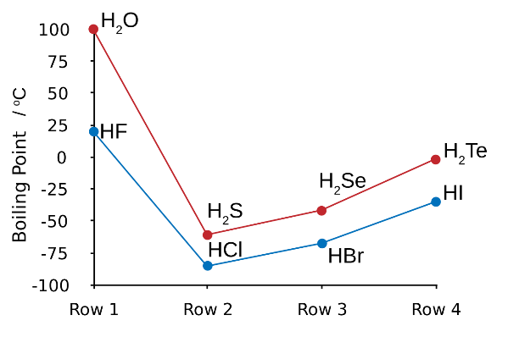

* 1. Explain why HF has a much higher boiling point than HCl, HBr and HI. (1 mark)

|  |
| --- |
|  |
|  |

* 1. Explain the increase in boiling point from HCl to HI. (2 marks)

|  |
| --- |
|  |
|  |
|  |
|  |
|  |

* 1. Draw two diagrams, one that shows the interaction of a potassium ion with a water molecule in solution and one that shows the interaction of a chloride ion with a water molecule in solution.

|  |  |
| --- | --- |
|  |  |

(4 marks)

1. Propane is a gas which is used to power gas hotplates whilst pentane is a liquid component of gasoline. Using your knowledge of intermolecular forces, explain why these compounds exist in different states at room temperature. (2 marks)

|  |
| --- |
|  |
|  |
|  |
|  |
|  |

1. What is vapour pressure? Explain how this property relates to the strength of intermolecular forces. (3 marks)

|  |
| --- |
|  |
|  |
|  |
|  |
|  |

1. For the following reactants, produce a balanced chemical equation, including states of matter.

(6 marks)

|  |
| --- |
| **Ammonium bromide reacting with silver nitrate.** |
|  |
| **Chromium (III) chloride reacting with sodium sulphate.** |
|  |

1. Explain why glaciers weighing tonnes are able to float in liquid water. (2 marks)

|  |
| --- |
|  |
|  |
|  |
|  |
|  |
|  |
|  |

**SECTION B: CALCULATION SECTION (16 marks)**

1. A laboratory technician wanted to determine the amount of iron in a mineral sample by reacting it with a solution of dichromate ions (Cr2O72-) according to the following chemical equation:

**6Fe2+(aq) + Cr2O72-(aq) + 14H+(aq) 🡪 6Fe3+(aq) + 2Cr3+(aq) + 7H2O(l)**

* 1. A solution of 0.05 molL-1 potassium dichromate (K2Cr2O7) was required for this test. Calculate the mass of potassium dichromate needed to prepare 250mL of solution. (3 marks)

A 4.3g sample of the mineral was ground and digested in acid to leach all of the iron into solution. Tin chloride (SnCl2) was added to convert all of the iron in the leach solution to Fe2+ ions. It was found that 28.2mL of the potassium dichromate solution was needed to completely react with all of the Fe2+ ions.

* 1. Calculate the percentage of iron in the mineral sample. (5 marks)

1. An analytical chemist wanted to perform a copper analysis by atomic absorption spectroscopy and needed to prepare a range of calibration standards to optimise the instrument. She began by preparing a working solution of copper sulfate (CuSO4) with a concentration of 250ppm. She then diluted this solution to prepare standards with concentrations of 2, 5 and 10ppm.

Including calculations, explain how she could prepare 100mL of each standard from the working solution. (6 marks)

1. A solution of magnesium carbonate has a concentration value of 163 parts per million (ppm). Express this value in moles per litre. (2 marks)

**END OF TEST**

Extra working space: